Brecon Golf Club
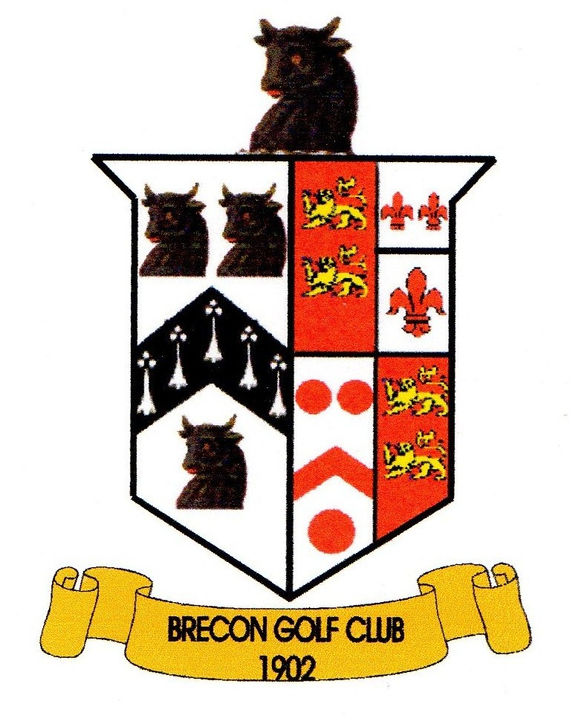
Stan Chapman Cup – Team Of 4
Sunday 18th August 2024
NAME | H/CAP | HOME CLUB
A.

B.

C.

D.

Phone No:

18 HOLE STABLEFORD BEST 3 SCORES ON EACH HOLE COUNT (Max handicap 28)

START TIME PREFERENCE  AM / PM? | Lunch or Tea Required? | ENTRY £15.00 per person  MEMBERS £10.00 per person  Optional 2’s SWEEP
 |  | Total Enclosed:£

Cheques should be made payable to “Brecon Golf Club”.
Please return completed entry form with entry fees BEFORE 12th August 2023 to:
Competition Secretary, Brecon Golf Club, Newton Park, Brecon, Powys, LD3 9PA.

