Brecon Golf Club
4 Ball Better Ball Open
The John Owen Evans Trophy
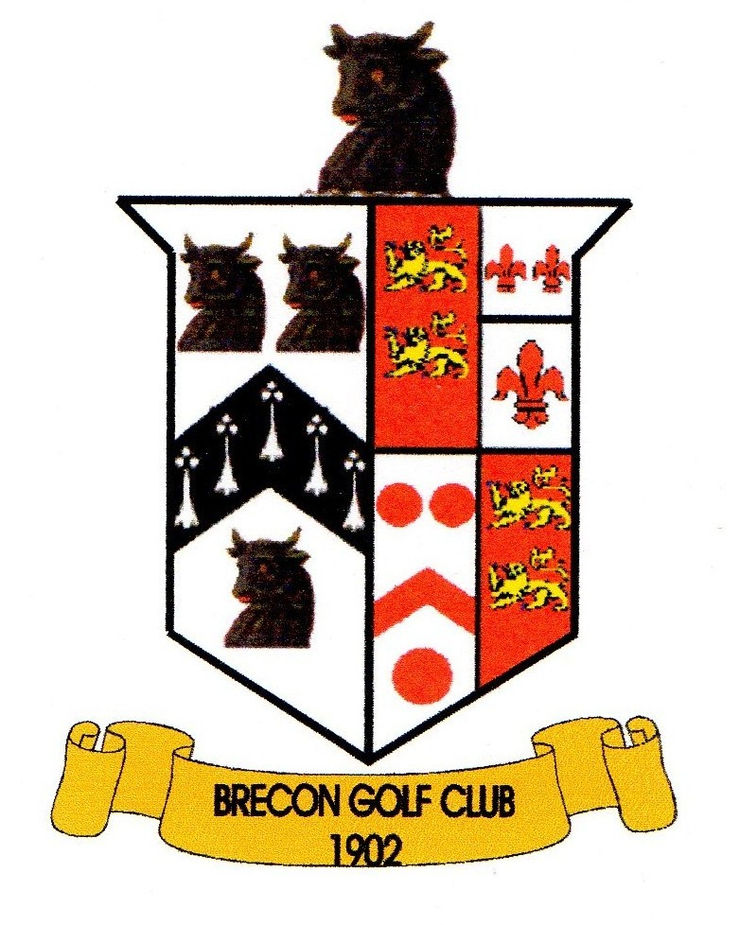
Sunday 15th September 2024

NAME | H/CAP | HOME CLUB
A.

B.

Phone No:

18 hole strokeplay - Max Handicap 24
Start Time Preference  AM / PM? | LUNCH / TEA  REQUIRED? | ENTRY £ 30.00 per pair  MEMBERS £ 20.00 per pair  + Optional 2's sweep
 |  | Total Enclosed: £

Cheques should be made payable to “Brecon Golf Club”.

Please return completed entry form with Entry Fees to Competition Secretary, Brecon Golf Club, Newton Park, Brecon, Powys. LD3 8PA - BEFORE MONDAY 9th SEPTEMBER 2024.

