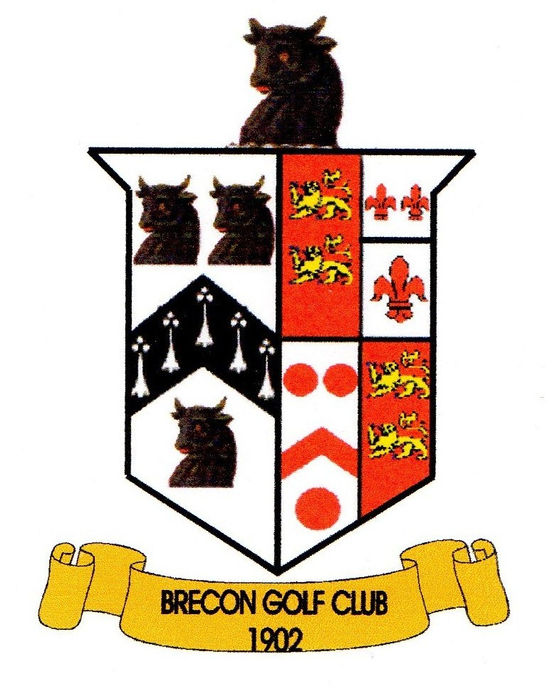
Brecon Golf Club

Mixed Individual Open ~
Gorkha & Khukuri
Saturday 11th May 2024

PLAYERS NAME | H/CAP | Male/  Female |  | HOME CLUB
Phone No:

18 hole strokeplay - max handicap
Men's 24 Ladies 36
Start Time Preference  AM / PM? | Bacon Roll or Meal required? | ENTRY £15.00 per person  MEMBERS £10.00 per person  + Optional 2's Sweep
 |  | Total Enclosed: £

Cheques should be made payable to “Brecon Golf Club”.
Please return completed entry form with entry fees, BEFORE 4th May 2024 to: Competition Secretary, Brecon Golf Club, Newton Park, Brecon, Powys, LD3 9PA.

